**NANDHA ENGINEERING COLLEGE**

(An Autonomous Institution, Affiliated to Anna University, Chennai)

# ERODE–638052



## A Project Report

***Submitted by***

# BOOMIKA P T (23AI009)

*In partial fulfillment for the award of the degree*

*of*

# BACHELOR OF TECHNOLOGY

# IN

# ARTIFICIAL INTELLIGENCE AND DATA SCIENCE

**DEPARTMENT OF ARTIFICIAL INTELLIGENCE AND**

**DATA SCIENCE**

What is Tableau?

Tableau is a powerful and easy-to-use data visualization tool that helps people understand data.  
It allows users to create beautiful charts, dashboards, and reports without needing to write complex code.  
With Tableau, we can turn raw data into clear, interactive visual stories to find trends, patterns, and insights.  
It is widely used in businesses, research, and education to make better decisions by seeing data visually.

Project: CLIMATE CHANGE IMPACT ON AGRICULTURE

## In this project, we are using Tableau to study and understand the impact of climate change on agriculture.

The main aim is to turn raw agricultural data into beautiful and interactive dashboards that show:

* Changes in crop yields over time due to climate change
* Regional differences in agricultural productivity
* Impact of temperature and rainfall changes on crop growth
* Identification of the most affected crops
* Trends in agricultural production across different seasons and years

**Steps in the Project:**

1. Connect Tableau to agricultural data (from an Excel file or database).
2. Clean the data if needed (remove errors or missing values).
3. Create visualizations like bar charts, line graphs, scatter plots, and heatmaps.
4. Build dashboards that combine different charts to show overall trends.
5. Analyze the dashboards to identify patterns, trends, and insights related to climate change and agriculture.

**Importance of This Project:**

* Helps farmers and agricultural companies understand how climate change is affecting crop production.
* Identifies regions most impacted by climate change and potential risks.
* Provides insights on how changing temperature and rainfall patterns are influencing agricultural yields.
* Supports better agricultural planning, policy-making, and climate adaptation strategies.

## Crop type VS Soil Health Index:

## Screenshot 2025-04-27 121210.png

## What This Chart Shows:

## This bar chart compares different crop types based on their Soil Health Index, providing insight into how various crops impact soil quality.

## The X-axis represents the Soil Health Index values.

## The Y-axis lists different crop types like Corn, Rice, Vegetables, Cotton, and Wheat.

## Longer bars indicate a higher Soil Health Index, meaning better soil health associated with that crop type.

## How We Built It:

## X-Axis (Soil Health Index):

## Shows numerical values indicating the soil health score associated with each crop type. Higher values suggest better soil conditions.

## Y-Axis (Crop Types):

## Lists the various crops analyzed (Corn, Rice, Vegetables, Cotton, Wheat).

## Bars:Each bar represents the Soil Health Index for a specific crop. This makes it easy to visually compare how different crops affect or correlate with soil health..

## Year VS Fertilizer Use KG per HA:

## Screenshot 2025-04-27 121858.png

## What This Chart Shows:

## This line chart illustrates the trend of fertilizer use (measured in kilograms per hectare) over the years.

## The X-axis represents the years (from around 1988 to 2025).

## The Y-axis shows the amount of fertilizer used per hectare (KG/HA).

## The line helps visualize how fertilizer application rates have fluctuated over time, highlighting periods of increase, decrease, and stability.

## How We Built It:

## X-Axis (Years):

## Displays the timeline of years, allowing us to track how fertilizer usage has changed annually.

## Y-Axis (Fertilizer Use KG/HA):

## Represents the quantity of fertilizer applied per hectare of land each year.

## Line:Each point on the line corresponds to a specific year's fertilizer usage rate, and the connecting lines show trends and variations over time.

## Country VS Average Temperature C

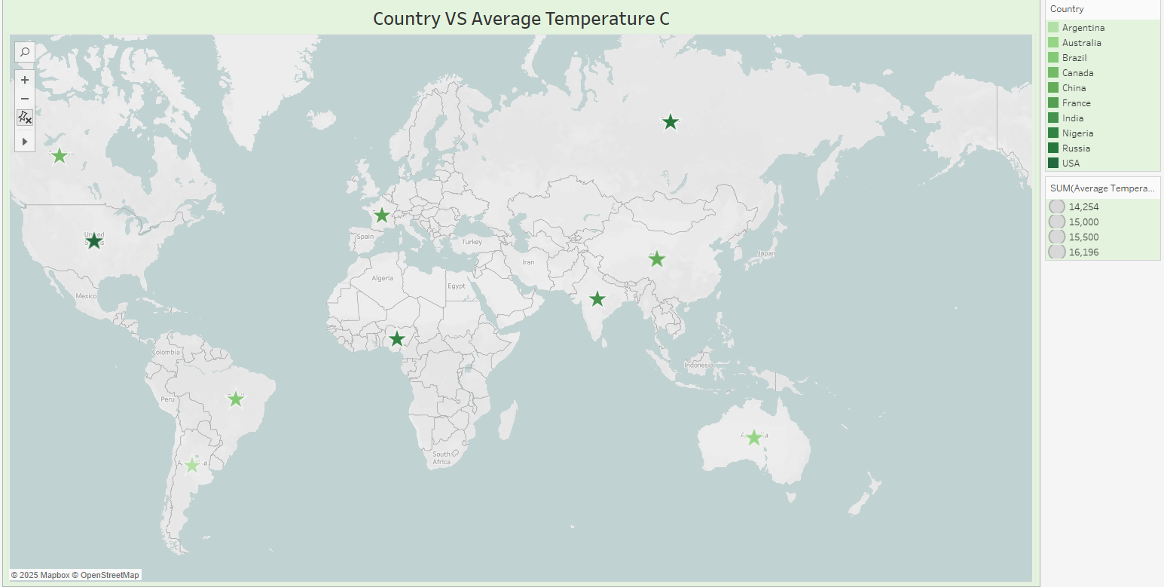

## What This Chart Shows:

## This map visualizes the average temperature (in degrees Celsius) across different countries around the world.

## Each star represents a country, with the size and color intensity indicating the average temperature values.

## The chart helps to easily identify and compare temperature patterns geographically across continents.

## How We Built It:

## Map (Geographic Plot):

## Countries are plotted on a world map based on their geographic coordinates.

## Markers (Stars):

## Each country is marked with a star, with varying sizes and shades of green depending on its average temperature.

## Color and Size Legend:

## Darker and larger stars represent countries with higher average temperatures, while lighter and smaller stars indicate lower average temperatures.

Country

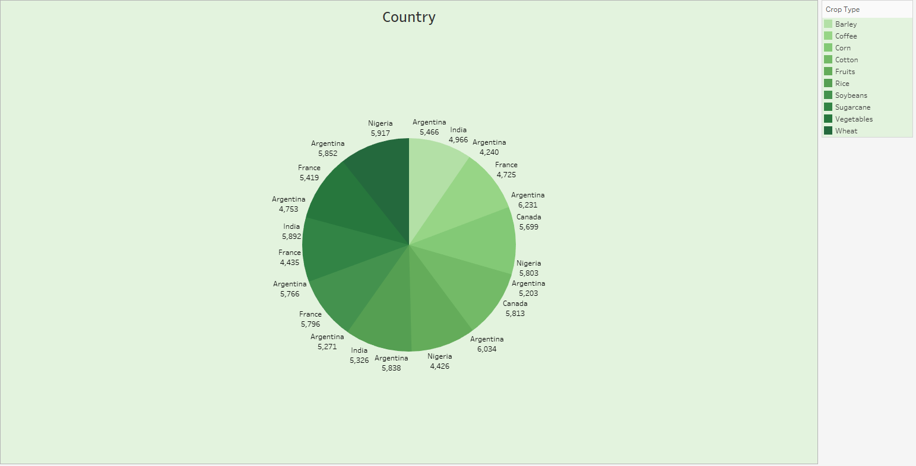

## What This Chart Shows:

## This pie chart illustrates the distribution of different crop types across various countries.

## Each slice represents a country's contribution to specific crop types, with the size of each slice proportional to the crop production or value.

## The chart visually highlights which countries dominate the production of certain crops and shows the relative share of each crop type.

## How We Built It:

## Slices (Countries):

## Each slice corresponds to a country and its associated crop type, differentiated by shade intensity.

## Color Coding (Crop Types):

## Different shades of green represent different crop types such as Barley, Coffee, Corn, Cotton, Fruits, Rice, Soybeans, Sugarcane, Vegetables, and Wheat.

## Labels:

## Each segment is labeled with the country name and the corresponding value, making it easy to identify key contributors.

## Crop Type VS Economic Impact Million USD:

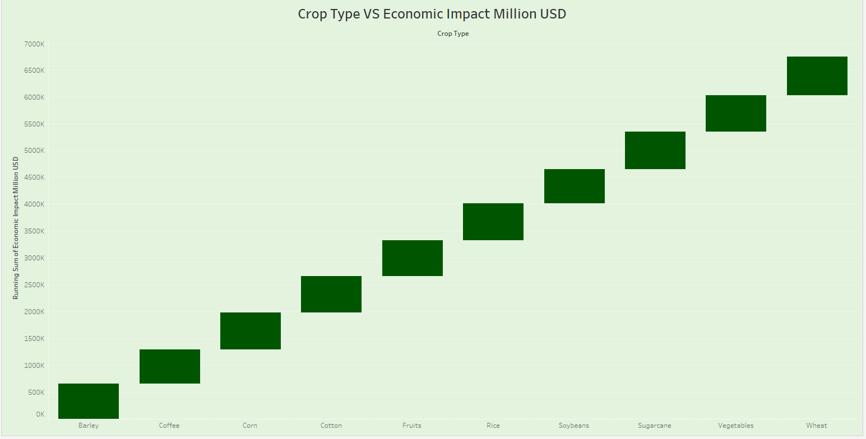

## What This Chart Shows:

## This bar chart illustrates the cumulative economic impact (in million USD) by crop type.

## The X-axis represents different crop types (e.g., Barley, Coffee, Corn, etc.).

## The Y-axis shows the running sum of the economic impact in million USD.

## Each bar represents the contribution of each crop to the overall economic value, helping us visualize which crops contribute most significantly.

## How We Built It:

## X-Axis (Crop Type): The X-axis lists various crop types, arranged in a specific order.

## Y-Axis (Running Sum of Economic Impact): The Y-axis displays the cumulative total economic impact in million USD as we move from one crop type to another.

## As each new crop is added, the total economic impact increases, forming a step-like progression.

Region VS Irrigation Access% :

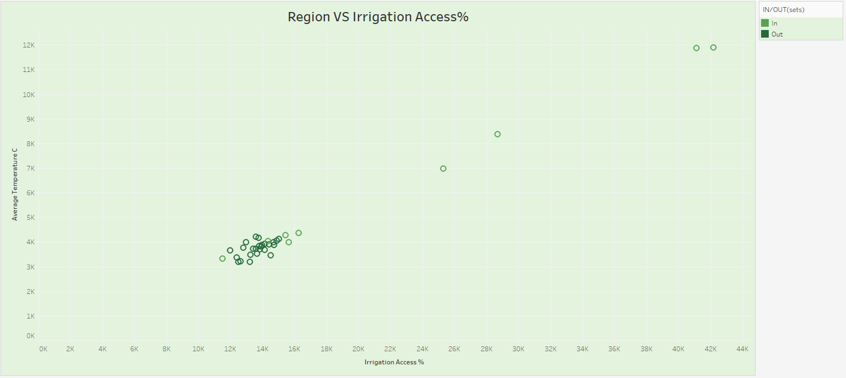

## What This Chart Shows:

## This scatter plot illustrates the relationship between irrigation access percentage and average temperature across different regions.

## The X-axis represents the Irrigation Access %, showing the proportion of land with access to irrigation.

## The Y-axis represents the Average Temperature (°C) for each region.

## Each point represents a region, and the color indicates whether it falls within a specified group ("In" or "Out").

## This helps identify any patterns or clusters, showing if regions with higher irrigation access tend to have different average temperatures.

## How We Built It:

## X-Axis (Irrigation Access %): The percentage of land area with access to irrigation systems in each region.

## Y-Axis (Average Temperature °C): The average temperature recorded for each region.

## Color Coding (IN/OUT): Points are colored based on a classification (e.g., regions categorized as "In" or "Out").

## Each point on the graph represents a different region's irrigation access percentage and average temperature.

## Project Overview

## This Climate Change Impact on Agriculture Dashboard analyzes various factors affecting agriculture globally, including soil health, temperature variations, fertilizer usage, irrigation access, and crop-based economic impacts.

## It provides meaningful insights into how climate change is influencing agricultural outputs and regional environmental conditions to support better decision-making for sustainability and farming practices.

## Key Insights

## Crop Type vs. Soil Health Index:

## ➔ Wheat and Rice show the highest Soil Health Index values among major crops, indicating better soil sustainability under their cultivation.

## Country vs. Average Temperature:

## ➔ Countries such as Argentina, Canada, and Nigeria exhibit varying average temperatures, helping to identify regional climate patterns affecting agriculture.

## Year vs. Fertilizer Use (KG per HA):

## ➔ Fertilizer usage trends show fluctuations over the years, with relatively stable usage rates post-2000, indicating efforts toward sustainable farming practices.

## Crop Type vs. Economic Impact (Million USD):

## ➔ Crops like Wheat, Vegetables, and Rice contribute the most significant economic impact, suggesting their crucial role in agricultural economies.

## Region vs. Irrigation Access %:

## ➔ Most regions cluster between 10K and 20K in irrigation access percentage, but a few regions have exceptionally higher irrigation access, potentially benefiting from better agricultural outputs.

## Country-Level Contributions:

## ➔ Nigeria and Argentina show notable agricultural activities, contributing significantly to overall crop production and soil health measures.

## Visualizations Used

## Bar Chart: Crop Type vs. Soil Health Index

## Map Visualization: Country vs. Average Temperature

## Line Chart: Year vs. Fertilizer Use per Hectare

## Pie Chart: Country Contributions to Agriculture Metrics

## Running Total Bar Chart: Crop Type vs. Economic Impact

## Scatter Plot: Region vs. Irrigation Access Percentage

## Conclusion

## The Climate Change Impact on Agriculture Dashboard delivers a comprehensive view of how environmental changes and farming practices are shaping global agriculture.

## By analyzing critical indicators such as soil health, temperature variation, fertilizer use, irrigation access, and crop-specific economic contributions, the dashboard offers valuable insights into sustainable agricultural practices and climate resilience.

## This tool supports policymakers, researchers, and agricultural businesses in making data-driven decisions to improve soil health, optimize resource usage, and adapt strategies for a rapidly changing climate.

## Overall, it is essential for promoting sustainable agricultural growth and ensuring food security in a warming world.